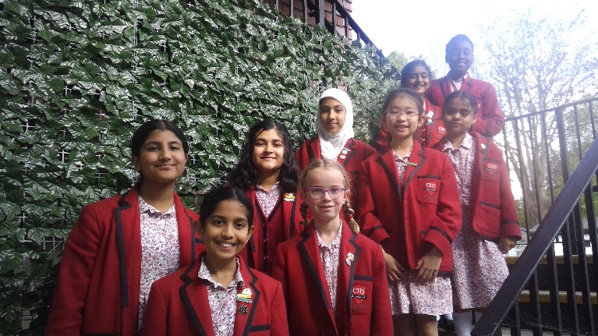
Art Teacher (Part-time - 0.4 FTE)
Start September 2024 or Jan 2025

At Cumnor House School, we pride ourselves on encouraging a genuine love for learning. From a very young age, we support our children in their development of a sense of curiosity, open-mindedness, perseverance, reflection, and critical thinking. This thirst for growth and knowledge is one that stays with them throughout their school years, meaning they enter each stage of their lives best prepared for the challenges and opportunities ahead.

The opportunity

We are seeking an experienced and qualified Art Teacher to work part-time at our thriving and happy Girls’ School. Small classes with enthusiastic and creative pupils make this a rewarding role. The successful candidate will oversee Art throughout the school and teach years 3-6 they will also help the more talented pupils to prepare for Art scholarships to selective Independent schools
Who are you?

The successful candidate will blend creativity and rigour in the classroom, have a contagious passion for Fine Art and the skill to propel our enthusiastic and hardworking pupils to excellent rates of academic progress.

Remuneration

- Competitive rate depending upon qualifications and experience
- School fee discount
- Free lunch
- Exclusive third-party discounts
- Professional Development

Application Process

To apply, please complete the Application Form and email it to Miss S Erdogan at Cumnor House School, at recruitment@cumnorhouse.com

Closing date: 15th April 2024
Interviews: w/c 22nd April 2024

Address: 1 Woodcote Lane, Purley, Surrey, CR8 3HB.

