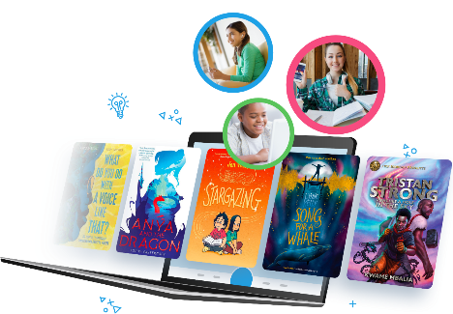
NEW eBook & Audiobook Library (Sora)
We have now launched our eBook and Audiobook lending library for Year 1 up. This is a library collection based around a school library consortium giving the boys a massive range of books. The library is accessed through the Sora app which works on their 1:1 device as well as any Apple / Android devices or any modern web browser.
We are currently growing the catalogue at the top end in part based on suggestions from the boys and will be continuing to do so.
Or access from chswebapps.co.uk
Watch our video quick guide to get started.
(iOS and Android are slightly different for sign-in. Here’s the 60 second guide to that.)
In addition to our catalogue of books you can easily integrate the Croydon Libraries collection. This can then be accessed alongside our school collection and will give an even wider range of books.
Croydon Libraries Collection
If you already have a Library Card for any of the Croydon Libraries, then you can add this straight away and get borrowing. Otherwise, you will first need to sign up for a Library Card. Visit the Croydon Libraries page here and then click ‘Join the library online’.
Make sure to record your library Card Number and PIN code. You will be emailed the card number but not the PIN code.
Here is a guide to adding the Croydon Library Collection to Sora.
Parents please be aware that the Croydon Libraries collection includes all age group books. In the video guide we show how to set a filter to hide the adult books. Parents will want to keep themselves aware of what their children are reading as the system will not restrict them.

